|  |
| --- |
|  |
| SOVY |
| Digital Calculator PO1_DGC_Keypad_Mang_CDD |

Table of Contents

1. Document Status 3

2. Document History 4

3. Reference Documents 4

4. Project Description 5

5. Software Context Diagram 5

6. Software features 6

7. Static Architecture 6

8. Component API’s 7

# Document Status

|  |  |
| --- | --- |
| Name | SOVY |
| Version | 1.0 |
| Status | Draft |
| Author | Andrew Ezzat |
| Date | 15/4/2021 |

# Document History

|  |  |  |  |
| --- | --- | --- | --- |
| Version | Author | Date | Change |
| 1.0 | Andrew Ezzat | 15/4/2021 | Initial Creation. |

# Reference Documents

|  |  |  |  |
| --- | --- | --- | --- |
| Ref. No. | Doc. Name | Version | Status |
| 1 | Digital Calculator PO1_DGC_GDD | 1.4 | Proposed |
| 2 | PO1_DGC_SRS_DigitalCalculator | 1.4 | proposed |

# 4.Project Description

“Sovy” is a simple digital calculator that performs basic mathematical operations and displays the operation on an LCD-screen, with an ON/OFF button and keypad for user input.

# 5.Software Context Diagram

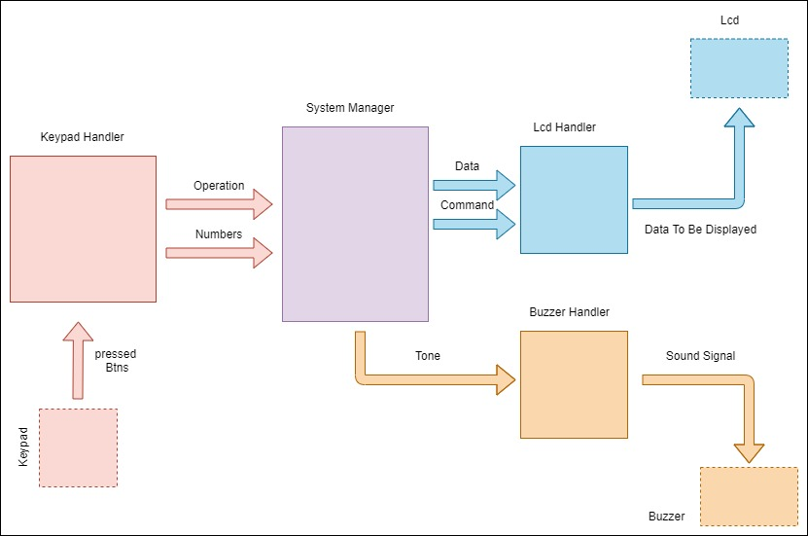

# 6. Software features

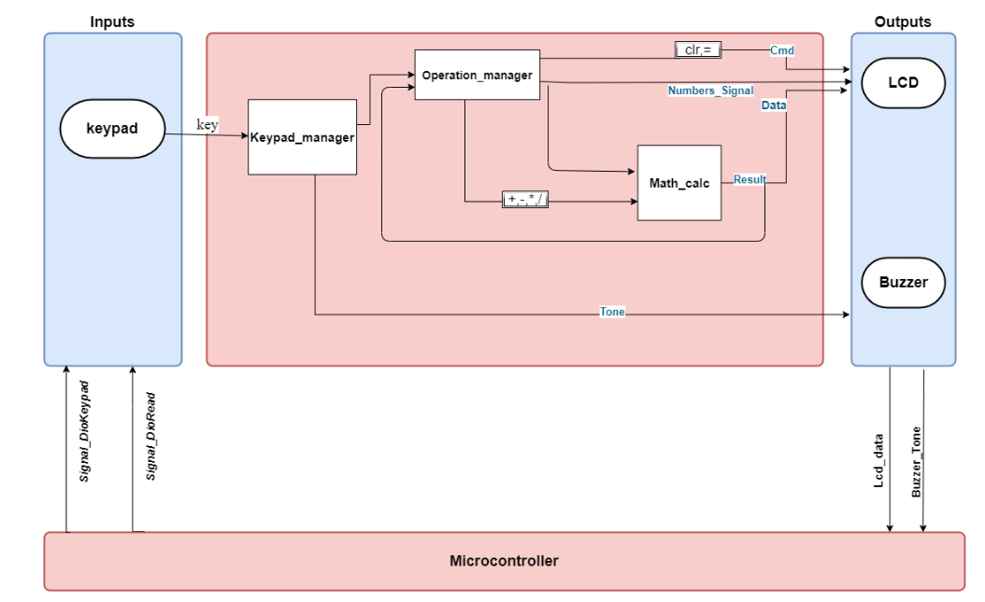

# 

# 7.Static Architecture

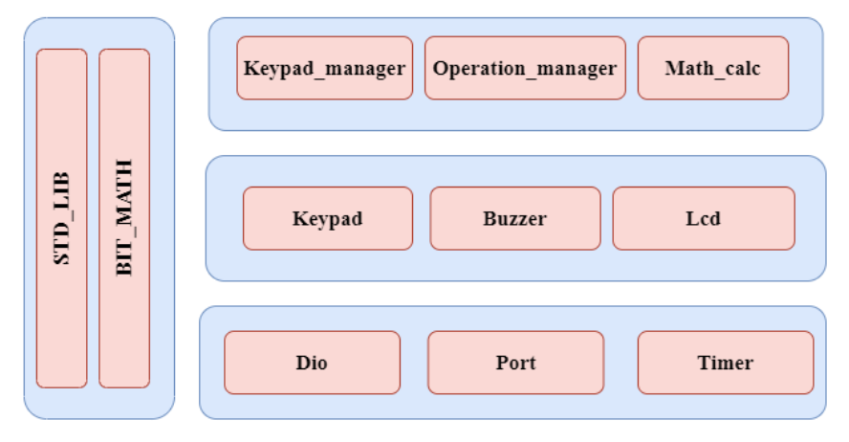

# 8. Component API’s

|  |  |  |  |  |  |
| --- | --- | --- | --- | --- | --- |
| **Req_ID** | Digital Calculator PO1_DGC_Keypad_Mang_CDD _001-V1.0 | **Covers** | |  | Req_PO1_DGC_GDD_KEYPAD_0015-V1.0 |
| **Description:** | It checks if key pressed and send this key to operation manger and the turn on the buzzer | | | | |
| **API** | ReturnStatus_e Keypad_Mang( void ) | | | | |
| **Parameters** | **Type** | | **Name** | | **Description** |
| None | | None | | None |
| **Return** | **Type** | | **Name** | | **Description** |
| ReturnStatus_e | | _____ | | STD_ERORR  E_OK -> If operation performed successful it returns 0  E_NOK -> If operation performed **not** successful it returns 1 |
| **Algorithm** |  | | | | |